**Position Sensing and Alignment**

**Engineering Guide**

**SpotOn** and **AlignMeter** will prove as excellent measuring devices for applications such as mirror alignment, articulated robotic beam delivery systems, quality control of lasers, pointing stability measurements and other various positioning and beam monitoring systems.

Large-area position-sensing detectors (PSDs) can detect and record the position of incident light beams. PSDs are used in many different applications, such as in the analysis of light sources or in the alignment of heavy machinery and targets when used in conjunction with a laser.

**Operating Principles of the Position Sensing Detector (PSD)**

A position-sensing detector (PSD) is a photoelectric device that converts an incident light spot into continuous position data. Many industrial manufacturers and laboratories around the world use PSDs in their daily work. PSDs are able to characterize lasers and align optical systems during the manufacturing process. When used in conjunction with lasers they can be used for industrial alignment, calibration, and analysis of machinery. It provides outstanding resolution, fast response, excellent linearity for a wide range of light intensities and simple operating circuits.

PSDs come in two types: **Quadrant detectors** or the dual-axis **Lateral Effect** detectors. The purpose of these two types is to sense the position of the beam centroid in the X-Y plane orthogonal to the optical axis.



In order to measure the X and Y positions from the PSD, four electrodes are attached to the detector and an algorithm then processes the four currents generated by photoabsorption. We supply both types of position-sensing detectors.

Quadrant Detectors

The Quadrant detector is a uniform disk of silicon with two gaps across its surface. For optimum performance and resolution, the spot size should be as small as possible, while being bigger than the gap between the cells.

Typically, the gap for **SpotOn** is 30µm or 10µm and the active sensing area is 77mm2 or 100mm2 (depending on the exact model).

When illuminated, the cells generate an output signal proportional to the magnitude of the illumination. **SpotOn**’selectronic card digitizes the output signal, and the host computer then processes the signal. The computer and software perform basic calculations of the position and power of the monitored beam.



Where A, B, C, D are the four quadrants respectively, and R is the radius of the incident beam illuminating the detector. The beam position is calculated using the following formulas:



where P (*total power*) = A+B+C+D

The output position is displayed as a fractional number or as a percentage figure, where the percentage represents the fraction of beam movement relative to the X or Y direction.

**Relation between Spot Size Measurement Range and Resolution**

As shown in the next figure, the system is out of measuring range in the X direction:



When the center of the beam is to the left side of the separating gap, thus:

Measuring range in X direction ±R

Measuring range in Y direction ±R

where R is the radius of the incident beam on the detector.

A more realistic value for X and Y range will be:

Working range X direction ±0.9 * (R)

Working range Y direction ±0.9 * (R)

**Resolution**

The system's resolution is very high (fraction of percent), and sub-micron resolution is easily achieved with small beams.

For example, an incident beam with a radius of 20µm will yield a movement sensitivity better than 0.1µm.

**Calibrating a Four Quadrant System to Engineering Units**

**SpotOn** system provides the user with an easy way to calibrate units to micrometers and microinches. In order to perform a calibration, the user needs to know the incident beam size in microns (micrometers or micro-inches). Then, open the position window and click on the ‘Setup’ button, choose the ‘Option’ tab, change the engineering units from “%” to “µm” and key in the beam size. The system will automatically switch to engineering units.

Self calibrating in cases that the beam size information is not available, is an easy task:

Mount your detector on a carriage, align the moving direction of the carriage to X or Y axis of the detector, then measure how much is the percentage movement as a function of the given movement as shown in the next figure:



For example let us assume that for a movement of 100 microns the detector's output will be 10% in X direction, then the overall range will be:

100 .............10%

X ...............100%

X= 100 * 100 = 1000 micron

10

Use this information and key it as in the previous case.

With quadrant detectors, position resolution and stability are excellent, but these parameters are relatively dependent on the spot diameter.

With their high resolution of 0.1µm (or even better) quadrant cells are ideally suited for precise centering, nulling alignment and tracking over relatively narrow ranges.

One of the best merits of a 4-Quadrant system is allowing high precision accurate position and power measurements simultaneously.

**Lateral Effect Detectors**

When your application requires measuring over a wide range, this is accomplished with high resolution and linearity, by using lateral-effect diodes.

This detector utilizes a single special photodiode, having continuous detection capability over it's entire area, regardless of beam-size and shape.

The 2-axis lateral effect diode acts as a pair of light controlled variable resistors for measuring the position of a light spot on X and Y direction. Most lateral effect diodes exhibit linearity within 0.5% over the central area (25% of active area), and 3% linearity out to 75% and with 5% on the periphery.

**SpotOn**, while being a computerized system, can compensate for this lack of linearity by offering calibrated lateral effect detectors, at a fraction of the cost of comparable detectors with the similar linearity.

There are three different kinds of PSDs available:

* One-dimensional

* Two-dimensional

* Circular one-dimensional

For best response to specific applications, **Duma Optronics** offers a range of single or duplex systems, as follows:

1. **Single system types:**

4-Quadrant or Lateral Effect detectors with various effective areas and different gap sizes, for such applications as:

**1.** Testing lasers for beam stability and power over a long period of time

**2.** Examining errors in slideways

**3.** Quality assurance of laser scanners

**4.** Displacement measurement in structural components

**5.** Measuring parallelism of rollers

To further facilitate accurate measurements, those detectors can be provided with an integral lens, calibrated to have its focal plane to coincide with the detector plane.

1. **Dual System types:**

For applications calling for measuring laser beam characteristics in multiple-degrees of freedom, a family of measuring instruments is offered as standard:

Dual Positioning system, composed of any one of the following combinations:

1. Two Lateral Effect detectors system
2. Two 4-Quadrant detectors system
3. One 4-Quadrant detector & one Lateral Effect detector system

For simultaneous measurements of one beam at two positions, or two different beams: Standard configurations of dual-detector systems assembled with optical elements and beam splitters are offered under the **AlignMeter** family as shown below.



Standard configuration of a system comprised of two detectors and one beam splitter.

Standard configuration of a system comprised of two detectors, one beam splitter and one lens, for simultaneous measurements of beam deviations, both Positional and Angular displacements.

**A list of Position Sensing Applications described**

The following list of PSD applications is intended to provide examples; it is not meant to be definitive. It would be impossible to list all the uses of these devices.

**Applications using Single Type systems:**

**1.** Laser testing

**2.** Controlling optical beam alignment

**3.** Measuring linear displacements

**4.** Measurement of the parallelism of rollers

**5.** Non-contact distance measuring system

**6.** Measuring the straightness in the gun barrel

**7.** Examining errors in slideways

**8.** Measuring the straightness

**9.** Measuring the flatness

**Applications using Duplex Type systems:**

**1.** Alignment of articulated arms

**2.** Alignment of lasers and laser tubes

**3.** Alignment of laser systems to a mechanical datum plane

**4.** Quality assurance of laser projector for laser scanners

The following pages will describe these applications in detail.

**Applications using Single-Type systems**

**Laser Testing**

Laser manufacturers frequently use PSDs to characterize their collimated lasers.

Using­ a PSD one can test the absolute power and power fluctuation of the laser, as well as the beam drift, centration, and alignment of the beam to the outer housing or tube. The **SpotOn** is particularly well suited to this application since it provides both a **graphic target display** for tracking the movement of the beam and a **chart display** that enables monitoring of beam characteristics over time.



**Controlling Optical Beam Alignment**

In certain applications it is necessary to align a laser beam to a target and to maintain the alignment with **high precision** over long periods of time.

To assure that the alignment is kept over a long period of time, an active feedback loop maintains the alignments by nulling the beam to the center of the target. The best detector to use for this application is the Quadrant detector because the center of a quadrant detector does not change with time or temperature. Nulling is controlled by a computer that processes the signals from the detector and adjusts a pointing mirror to re-center the beam.



**Measuring Linear Displacements**

A laser is directed to a moving mirror or a retroreflector. The measuring detector is placed to receive the reflected beam. Moving the mirror target parallel to the original position will generate a linear displacement on the detector surface thus enabling a non-contact measurement of the mirror linear displacement.



**Measurement of the Parallelism of Rollers**

A laser (designated as ‘S’) is mounted on a V-Block (‘P’) with two spirit levels (‘L’) on the top surface.

The V-Block is placed on the first roller and leveled in longitudinal and transverse direction.

The **SpotOn** system (‘A’) with lens is adjusted to the laser and then the block is transferred to the second roller which is then adjusted to the **SpotOn** system, so the longitudinal level shows zero.

After this, both axes are parallel to each other.

The difference between the first reading and the second reading in position is divided by the lens focal length, thus providing the inaccuracy of the parallism.

A - SpotOn system

W - Roller

S - Laser

P - V-Block

L - Level



**Non-Contact Distance Measuring System**

The system uses the technique of optical triangulation. By projecting a laser or a LED on a surface, and then measuring the scattered light position by an optical system and a PSD, it is possible to determine the distance to the object. The distance can be measured with very high precision and speed due to the outstanding linearity and resolution of the PSD.

The ability of the PSD to operate with various light intensities makes the measurement system insensitive to ambient light.

Industrial applications of this technique are:

1. Control level of molten iron
2. Guide robots during welding of thin metal sheets
3. Perform quality check of car bodies and engine parts
4. Examine road condition at a speed of 90 km/h
5. Vibrations measurements



**Measuring the Straightness in a Gun Barrel**



A **SpotOn** system is mounted on a guideway, having the gun’s caliber. A laser attached to the gun breech is directed to the **SpotOn** detector creating a **straight** optical path. As the guideway moves, the readings of the detectors will change according to the barrel deformation.

**Examining Errors in Slideways**

When used in conjunction with a laser, a dual-axis lateral-effect detector can measure tolerances and errors in mechanical devices with high precision. To measure errors in slideways, a lateral-effect detector is rigidly mounted perpendicular to the length of a traveling carriage, and a laser is aligned to the detector to define a straight optical path. As the carriage moves along the slideways, the lateral-effect detector measures changes in the position of the laser beam in two axes perpendicular to the direction of motion. Any changes in beam position readings will indicate deformities in the rails, play in the bearings, or both.

In cases where long travel is expected and/or strain induced by the detector head cable is not tolerable, the PSD can be replaced by a later-displacement, hollow retro-reflector. In this arrangement, the detector is mounted parallel to the laser, and light is reflected back into the PSD. Because of the retro-reflection effect, the beam position readings will be twice the actual movement of the carriage. Similar PSD based metrology systems can be used to measure characteristics such as surface flatness, squareness, and straightness.



Configuration for measuring errors in slideways.

Configuration for measuring errors in slideways, **using a retro-reflector.**

**Measuring the Strightness**

Determining the difference in height is achieved by two possible ways:

* Either using a retroreflector unit in an arrangement similar to the one explained in the “Examination of Slideways”, or by
* Monitoring angular changes when moving a detector-lens assembly.

When used in conjunction with a lens, a dual lateral-effect detector can measure angular deviations of an incoming beam.

To measure errors of straightness over long distances the calibrated lens detector is rigidly mounted perpendicular to the incoming beam and moved along its path. Any changes in the angular position of the incoming beam are recorded to generate straightness deviations.

**Mounting a lens on the SpotOn detector head (AngleMeter solution) :**

The angular reading is provided by the following formula:



 Where is the **SpotOn** reading and F is the lens focal length.

**Measuring the Flatness**

The straightness of the 8 lines AC, BD, etc., is measured. Since each line has two common measuring points with other lines in other directions of measurement, the various contour lines can be linked together. Evaluation gives a topography of the measured surface.

L - Guide

B - Laser source (**collimated**)

U - Deflection mirror

S - **SpotOn** with mounted lens

ML- Measuring Lines

**Applications using Duplex-type Systems**

A combination of two PSD’s

By combining two detector heads the Position and Angular movements of a laser beam is computed and simultaneously displayed by a special software package, a solution offered by the **AlignMeter** system.

**System Characteristics:**

**Construction**

The two detector heads are combined by a beam splitter that splits the beam in two:

-One part is directed towards a bare detector for Position monitoring.

-The second part is directed to a lensed system for Angular monitoring.

**Main Applications**

1. Laser beam monitoring
2. Alignment of robotic arms
3. Examining errors in slideways and optical tables

A variety of lenses and combinations are offered.



**Alignment of Articulated Arms**

The **AlignMeter** can serve as an accurate and simple device for the alignment routine of robotic arms or articulated arms.

The instrument can measure both the positional and angular beam runout of the articulated arms used as part of the laser beam delivery system on several of medical laser products.

A typical articulated beam delivery arm comprises of a series of hollow tubes connected to rotational mirror knuckles. The beam travels through the tubes and is directed by the reflected mirrors along the tube axis. Connecting several knuckles and tubes allow multiple degrees of freedom, which is built by rotating each tube in respect to each other. This multiple degrees of freedom articulated arm can deliver the beam to a working volume by hand moving the end tip of the arm. Building a roboting beam delivery arm is a very challenging task due to the alignment problems of the rotating mirrors in the knuckles.

The design process of the **AlignMeter** was specifically targeted to solve these problems, and allow fast and accurate alignment. The alignment process is based on the alignment of each knuckle from the first (closest one to the laser) to the last, and is performed by replacing the down stream mirrors with the **AlignMeter** system to align the non-replaced mirrors.

**Solution 1 - Static:**

A calibrated **AlignMeter** assembly can be easily mounted on a robotic arm, by using the adapting nut. If the mechanical datum is accurately aligned relative to the optical axis of the robotic arm, then the **AlignMeter** will provide the centration deviation and angular deviation instantaneously.

**Solution 2 - Dynamic:**

In case the mechanical datum is not accurate enough for the application you can mount the **AlignMeter** at the elbow as in the previous case and then perform the usual rotation of the arm. The beam deviation will be recorded by the AlignMeter as a circle. The user must then align the previous elbow so that the “circle” will only be one point.

**Calibrating the AlignMeter:**

For calibrating purposes the software enables defining a reference point as the new “zero” of the **AlignMeter**; This function is called “Catch” and when operated will cause the system to declare this center as “Zero”. This new center will be displayed as center of alignment and all other systems can be aligned to it using the previous methods.

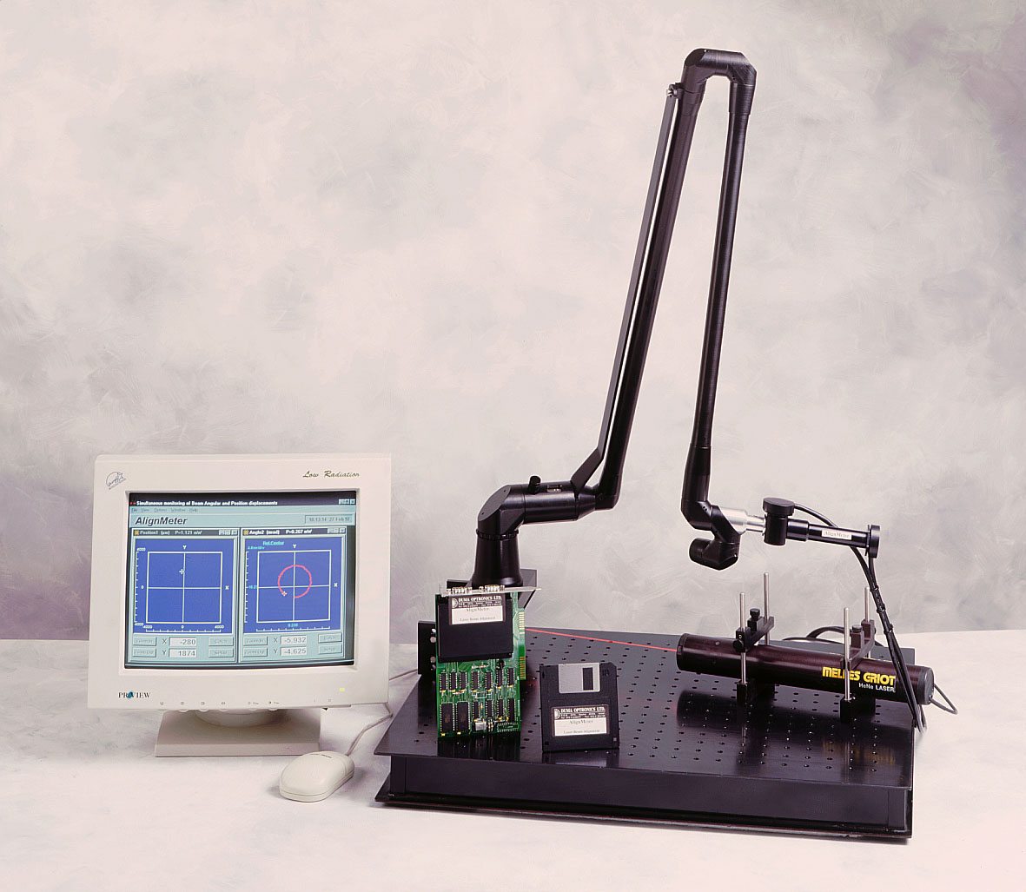

**Alignment of Lasers and Laser Tubes**

The **AlignMeter** can serve as an accurate and simple device for the alignment routine of lasers or laser tubes.

The instrument can measure both the positional and angular beam runout with respect to the laser housing. Using the AlignMeter and a customized calibration procedure as the mechanical housing of the laser can be aligned to coincide with the laser beam longitudinal axis within a fraction of a miliradian (up to 0.01 mrad) and concen­tricity­ of a few microns.

**Solution 1 - Static:**

A calibrated AlignMeter assembly can be easily mounted on an alignment tool, by using the adapting planes. The alignment tool will then be used to calibrate the lasers in the production line. Each laser will be mounted on the alignment tool and the laser deviations (both Position & Angle displacements) will be recorded by the AlignMeter­, including a printed report. Alignment of the lasers to the mechanical datum plane is then performed by moving the laser in respect to datum plane until the laser beam is perfectly aligned to the mechanical mounting planes.

**Solution 2 - Dynamic:**

In case the mechanical datum is not accurate enough, and for increased accuracy, the same system can be used as in the previous case, but with one difference - after mounting the laser tube on the alignment tool, one can rotate the laser tube. Beam deviations will be recorded by the AlignMeter as a circle on both the Position screen and the Angle screen. The user can then align the laser tube to a minimum deviation possible.

**Quality Assurance of Laser Projector for Laser Scanners**

Assuming the projector’s mounting surface to be at the right tolerance for **repetitive production,** the following equipment is needed:

1. Two **SpotOn** PSDs
2. Text fixture

The proposed system will monitor that the location of the beam is accurate as well as the angular pointing.



The first **SpotOn** head will monitor the incoming X1, Y1 coordinates to be at a specified allowed value.

The second **SpotOn** head will provide addition X2, Y2 coordinates.

The angle of the beam is calculated by:



Moreover, the system will provide **long term stability** data of power and position.